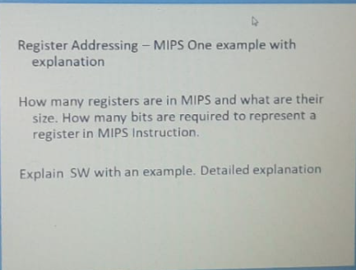

1. Register addressing :

The simplest addressing mode is the register addressing.   
Register addressing is a form of **direct addressing**. The value in the register is an operand instead of being a memory address to an operand.

* Operands are in a register. •
* Example: add $3,$4,$5 •
* Takes n bits to address 2n registers
* Example: MOV AX,CX (move the contents of CX register to AX register)

1. 32

The **MIPS** processor has one standard **register** file containing 32 32-**bit registers** for use by integer and logic **instructions**.

1. Sw:

* The SW instruction stores data to a specified address on the data memory with a possible offset, from a source register.
* It's syntax is:  
  **SW $source register's address, offset($destination register's address)**.
* The sample SW instruction demonstrated in the datapath above is **SW $2, ($5)**.